# Christmas Cheer Laser, part 3

## PowerShell Drives

PowerShell has broadened the concept of drives to include containers in general (not to be confused with Docker containers.) PowerShell treats many things that have the tree structure you are used to seeing in directories the same way as it treats directories. This is why PowerShell calls the dir or ls cmdlet “Get-ChildItem”. You can get the listing of Environment variables the same way you list a directory.  
Get-ChildItem Env:

On a Windows machine, the hard drives (C:, D:, etc.), the Environment variables (Env:), the registry (HKCU: and HKLM:), the certificate store (Cert:) are all accessible with the Get-ChildItem cmdlet. Many features of other Microsoft products like Active Directory and SQL server are accessible this way as well.

The aliases for Get-ChildItem on a Windows machine are dir, gci, and ls, but ls is missing on this terminal.

## Answers to Previous Questions

1. Find the message (and a parameter, too) in the command History  
   Get-History shows us most of what we need, but line 9 is truncated.  
   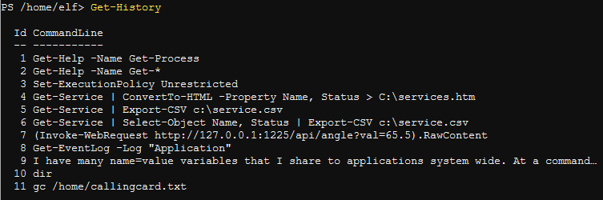  
   Notice that line 7 has the value for angle, angle?val=65.5  
   Get-History | fl shows us the entire line.  
     
   <snip>  
   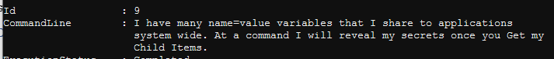
2. The answer to the previous question includes, “name=value variables that I share to applications system wide.” That’s a strong hint to tell you where to look next. The terms “variables”, “share to applications system wide “, and “name=value” are all useful hints.  
     
   The name=value variables are environment variables. PATH is a common environment variable. You can see them with  
   Get-ChildItem Env:   
   (dir env: or gci env: would also work.)

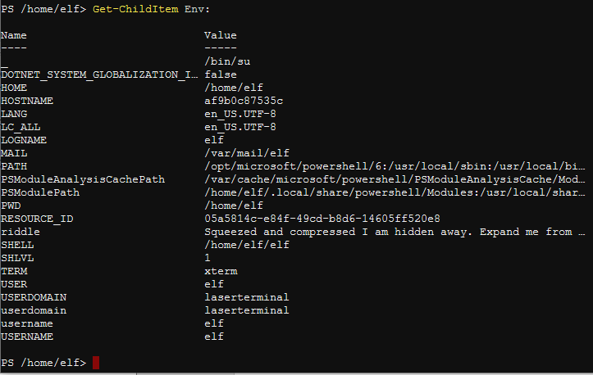  
Another ellipsis! Since we know the answer we need is in riddle, we can treat it just as if it were a file:  
dir env:riddle | fl  
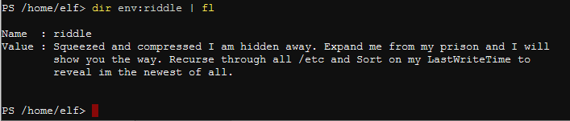

## Get-Member

PowerShell deals with objects, not just text, passed down the pipeline with the pipe symbol ( | ) . We must have a way to learn what the contents of an object are, and the Get-Member cmdlet does that for us. In this case the riddle tells us we need to sort something on LastWriteTime. Since we are using Get-ChildItem (or dir) we can guess that LastWriteTime is a property of those objects. We can test that by piping the output of Get-ChildItem into Get-Member.  
Get-ChildItem | Get-Member  
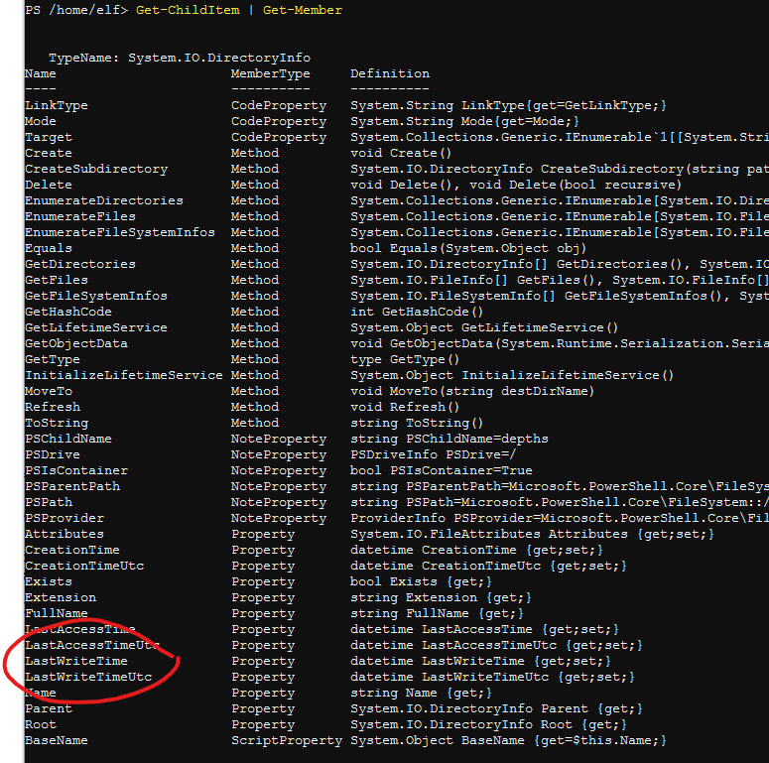

There is a property of the object called LastWriteTime.

To answer the riddle, you need to get a listing (recursively, meaning you have to include all sub directories) of the /etc directory, then pipe these results into Sort (Sort-Object) and sort the results using the LastWriteTime property to find the newest file. By default, Sort-Object will put the oldest object at the top and the newest at the bottom. Once you have found the file, you need to expand or decompress the file. PowerShell has a cmdlet for that, you just need to find it.

## Question

1. What riddle do you find inside the archive?